Scenario 1: Guest Registration and Access

1. Guest visits the backend website for the eBook.

2. The website displays a welcome message and provides options for registration or continuing as a guest.

3. The guest chooses to register and is directed to the registration page.

4. The guest enters their name, email address, and password, and submits the registration form.

5. The website verifies the entered information and creates a new user account.

6. Upon successful registration, the guest is redirected to the login page.

7. The guest enters their email address and password and clicks on the login button.

8. The website validates the login credentials and grants access to additional features and content as a registered user.

9. The guest can now read books, bookmark pages, and customize their reading preferences.

Scenario 2: Guest Continues as a Guest without Authorization

1. Guest visits the backend website for the eBook.

2. The website displays a welcome message and provides options for registration or continuing as a guest.

3. The guest chooses to continue as a guest.

4. The website allows the guest to explore the site but restricts access to book content and certain features.

5. The guest can view book summaries, author information, and other non-restricted content.

6. If the guest attempts to read a book or access restricted features, a prompt appears, asking them to authorize or register to gain full access.

Scenario 3: User Login and Book Selection

1. User visits the backend website for the eBook and sees the login page.

2. The user enters their email address and password and clicks on the login button.

3. The website verifies the login credentials and grants access to the user's account.

4. After successful login, the user is redirected to the homepage.

5. The homepage displays recommended books, recently read books, and other personalized content.

6. The user can search for books using filters, browse different categories, or explore authors.

7. Upon selecting a book, the user can access the book's content, read chapters, and interact with features like bookmarking, highlighting, and taking notes.

Scenario 4: Admin Management of eBook Content

1. Admin logs into the backend website using their admin credentials.

2. The website verifies the admin's login details and grants access to the admin dashboard.

3. The admin dashboard displays various management options, such as user management, book management, and content moderation.

4. The admin can add, edit, or delete books from the website's collection.

5. The admin can review and moderate user-generated content, such as book reviews and comments.

6. User management allows the admin to view user profiles, manage user roles, and handle user-related issues.

7. The admin can generate reports, analyze website statistics, and perform other administrative tasks to ensure the smooth functioning of the eBook website.

1. Home page

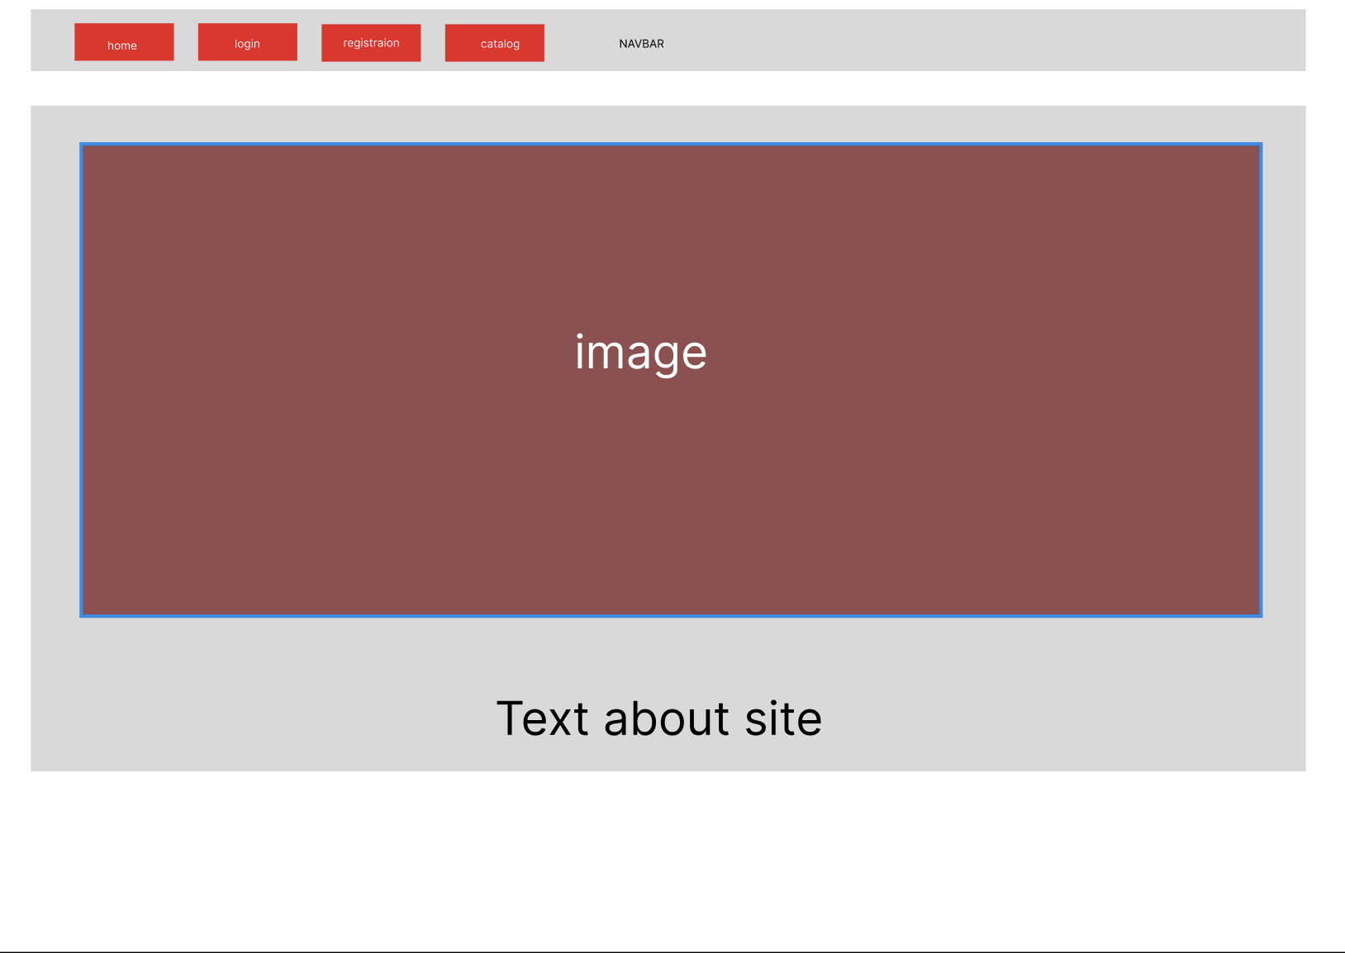

1. Catalog page

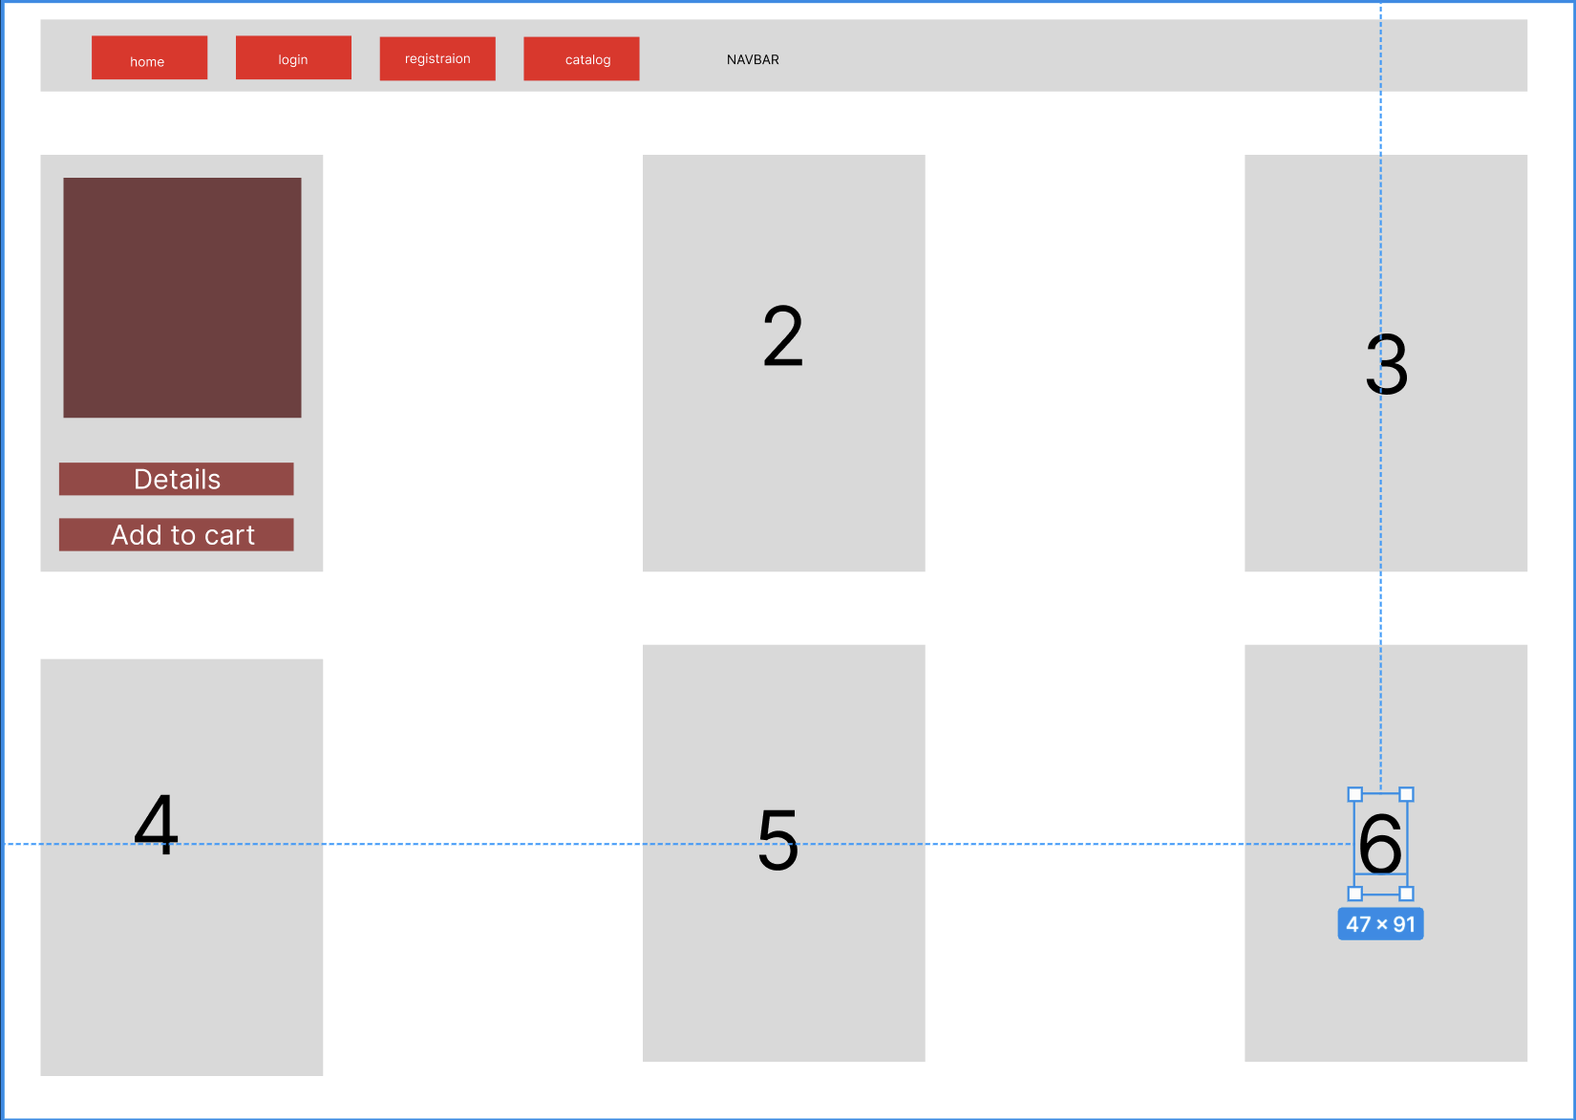

1. Book page

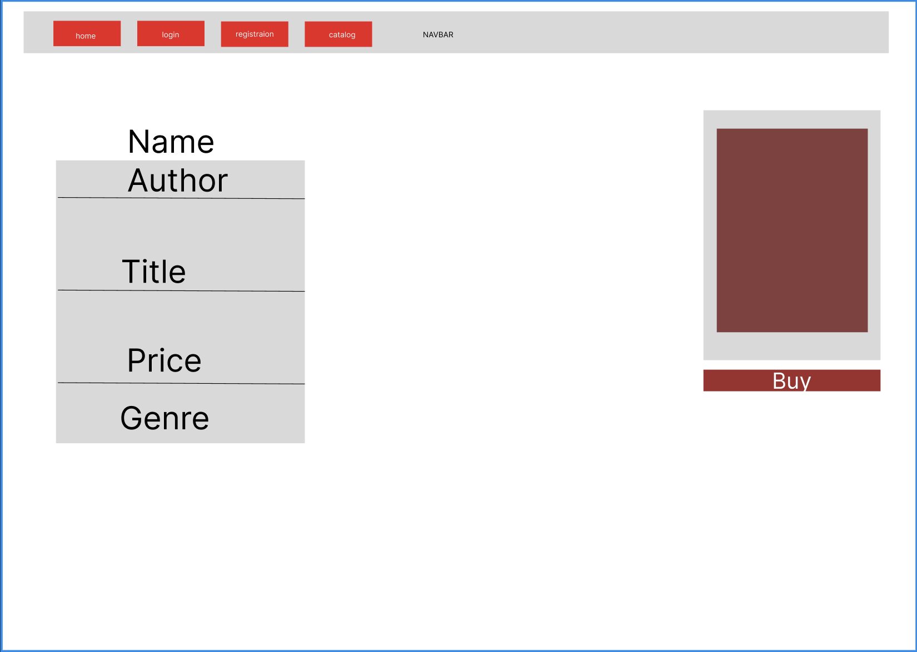

1. Login and Reg pages

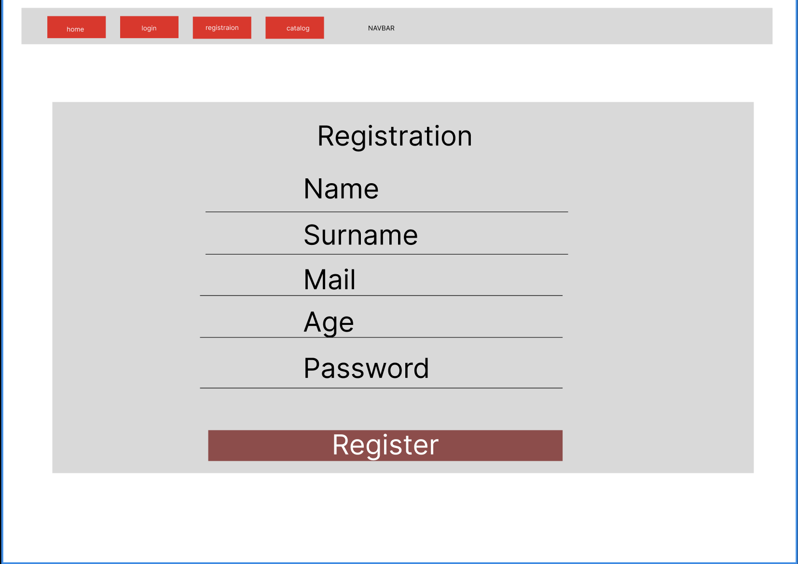

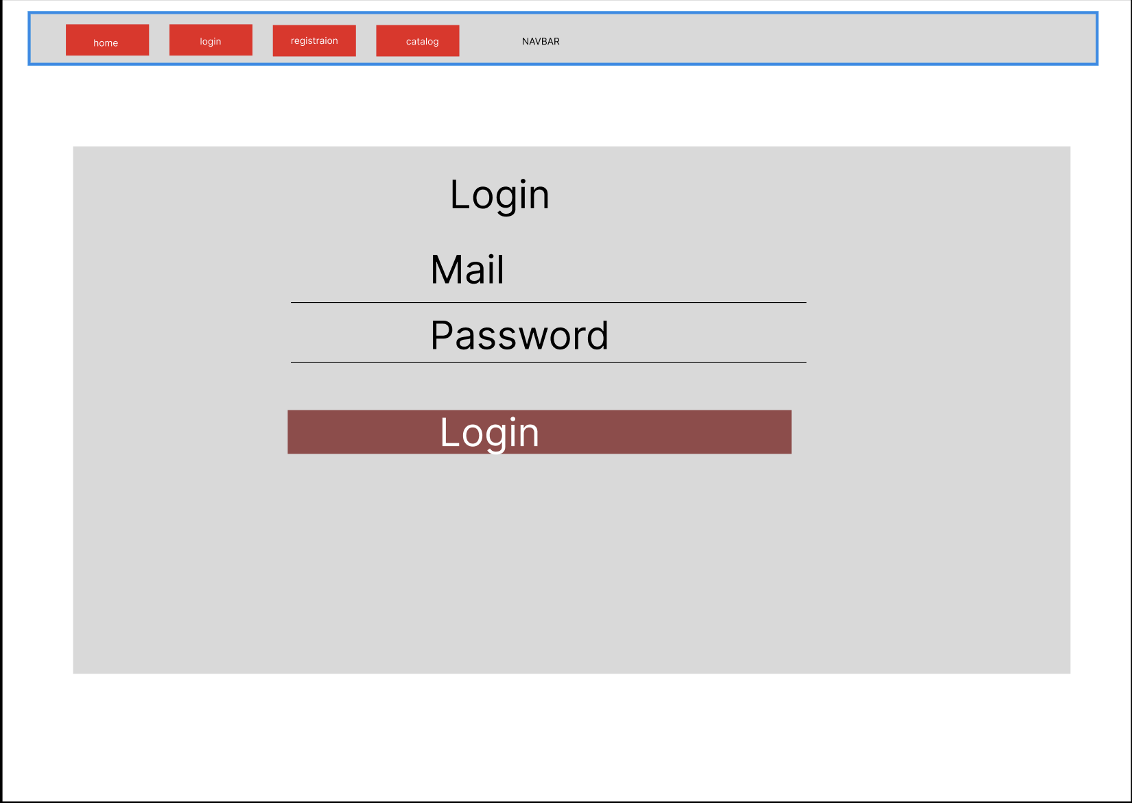

1. User Profile

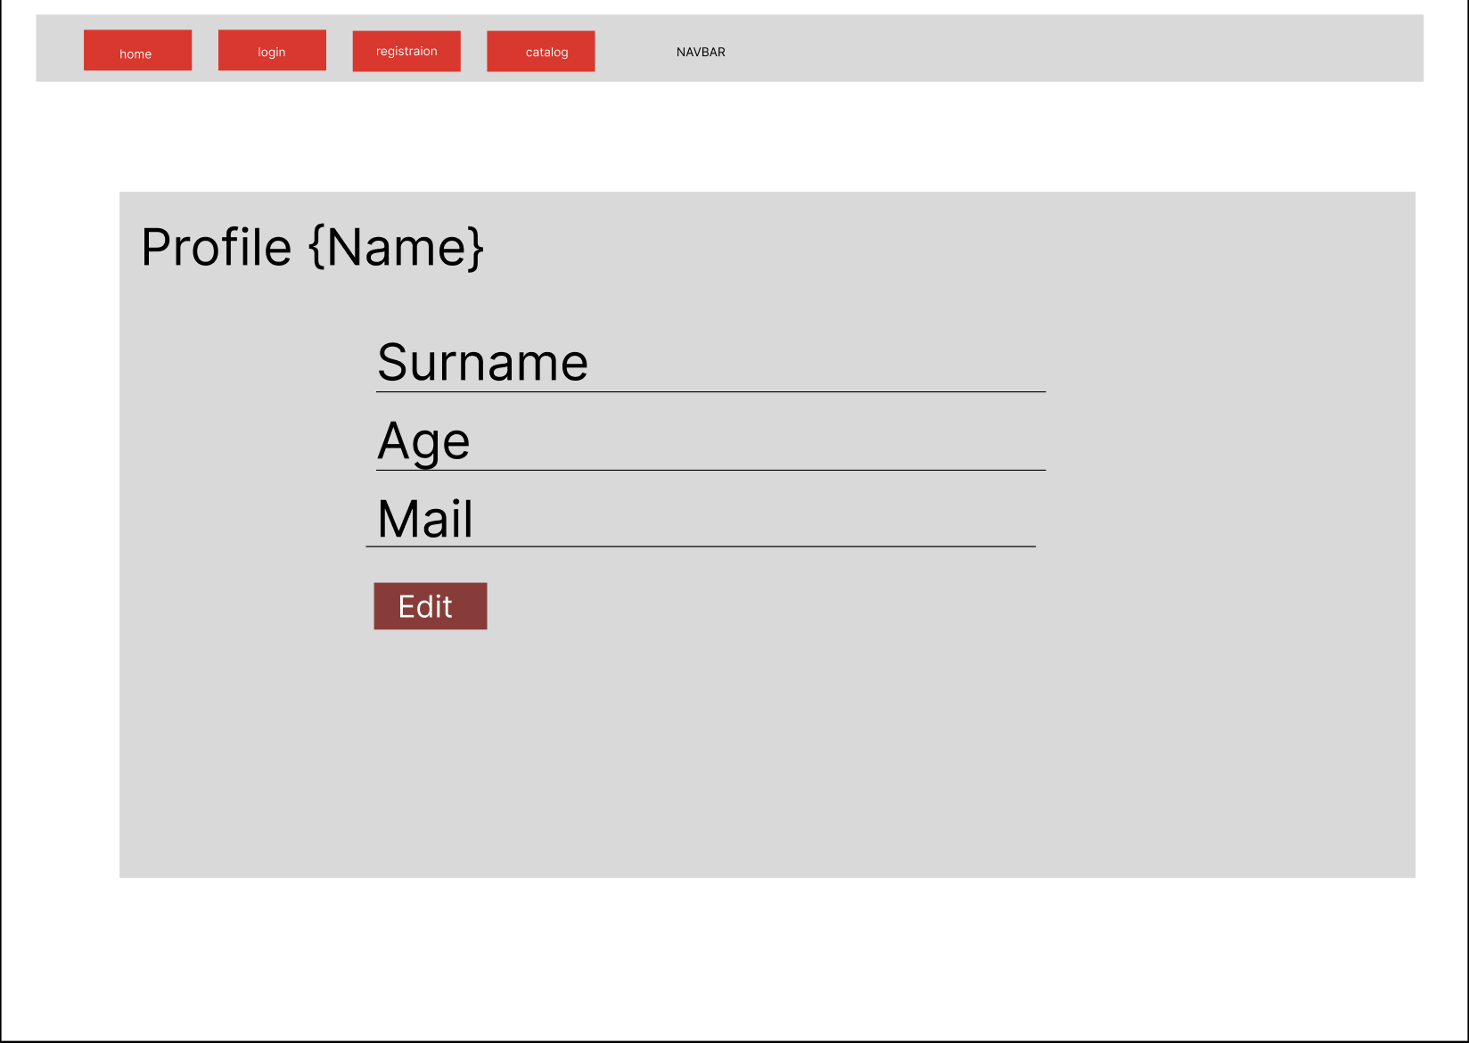

1. Admin pages Users/Books manipulation

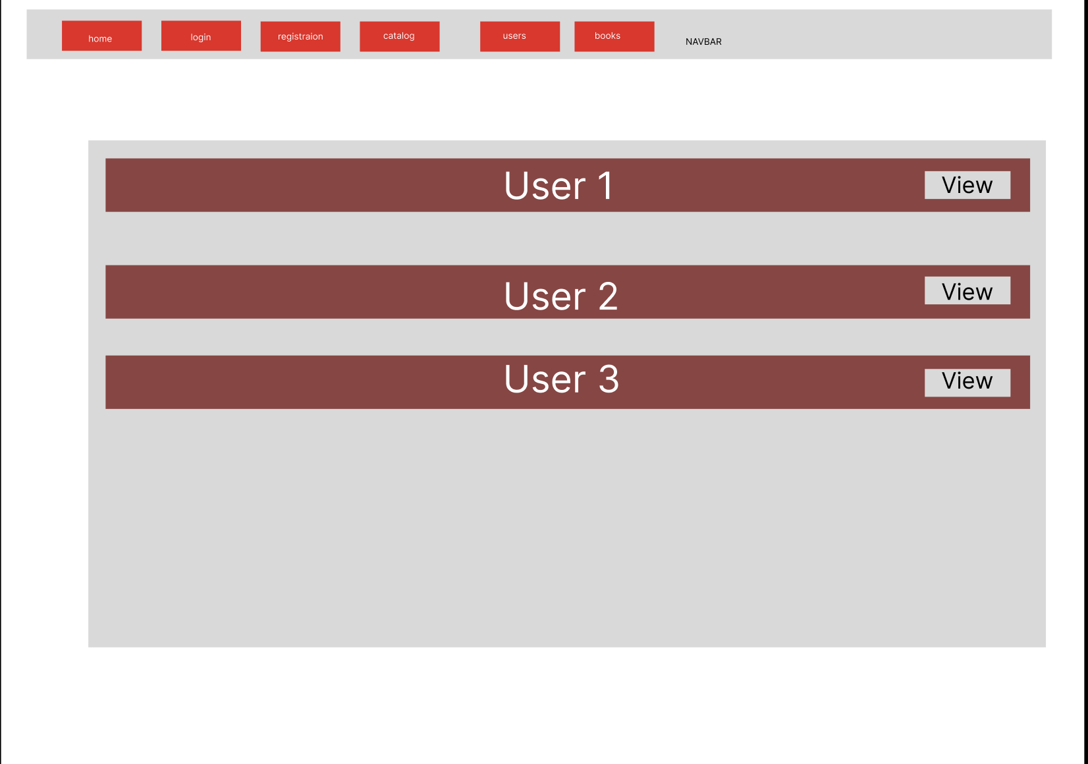

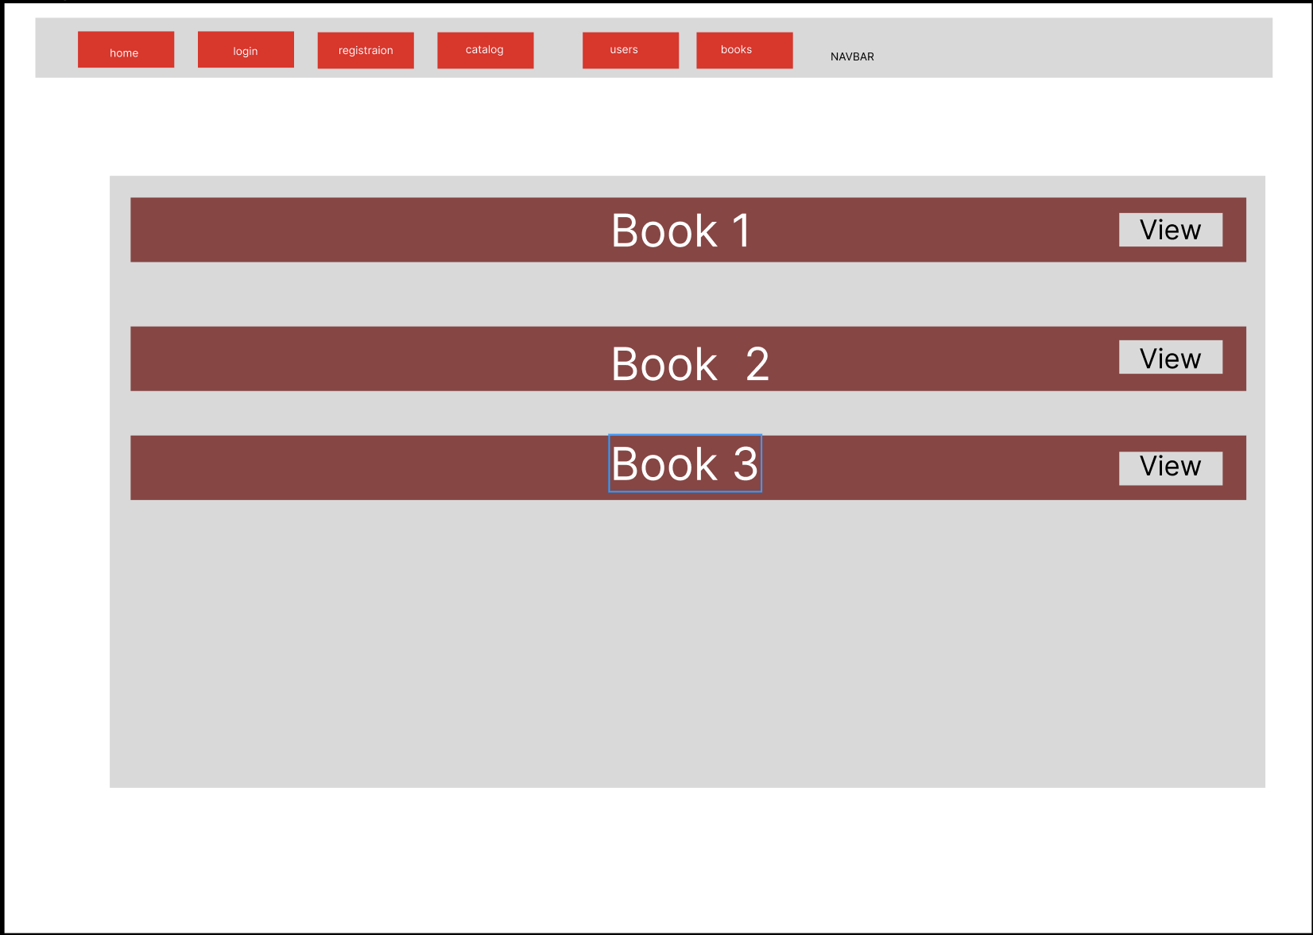

1. Payment page

